Introduction

**What is the purpose of this project:**

To create a website that shows my projects which I have created using adobe Photoshop, blender, adobe after effects and adobe lightroom.

**Scope of the project**

**Project display**

**Detailed project display**

* **Time**
* **Tools used**
* **Purpose of the project**
* **description of the project**

**Contact form (page for my contact details)**

Design Elements

**The color pallet of the project**

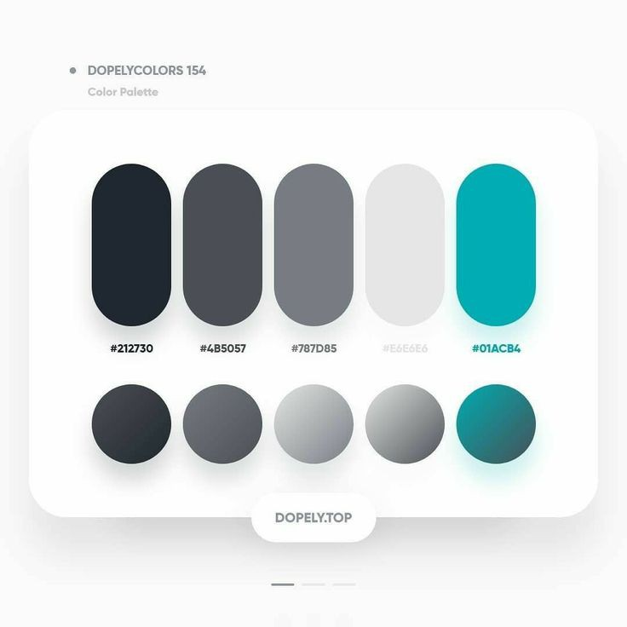

**Layout (Prototype layout of the website)**

Development

Tools to be used

**Frontend**

HTML-for the structure of the website

CSS-for the styling of the website

Pinterest-color pallet inspiration and website structure inspiration

Freepik-Icons and Symbols (Resource page)

Canva-to create the prototype layout of the website

**Backend**

JavaScript-to add functionality to the website

Python(flask) -python for backend development

**Database**

MySQL-for the database to store data

**Other**



Functionality

Give a view for all projects

Show project details

Move to next page to see who created the project and the details of the author

Add new projects to the website

**Success Criteria**

* **Metrics for Success**: Define how the success of the project will be measured.

Successful deployment of the website

Positive user feedback

Time frame

2 months

1 week for prototype design

6 weeks for development of project

1 week for testing and getting user feedback

5 days for deployment